**DIGITAL MARKETTING**

Assignment 3 - Creating a social media poster using canva

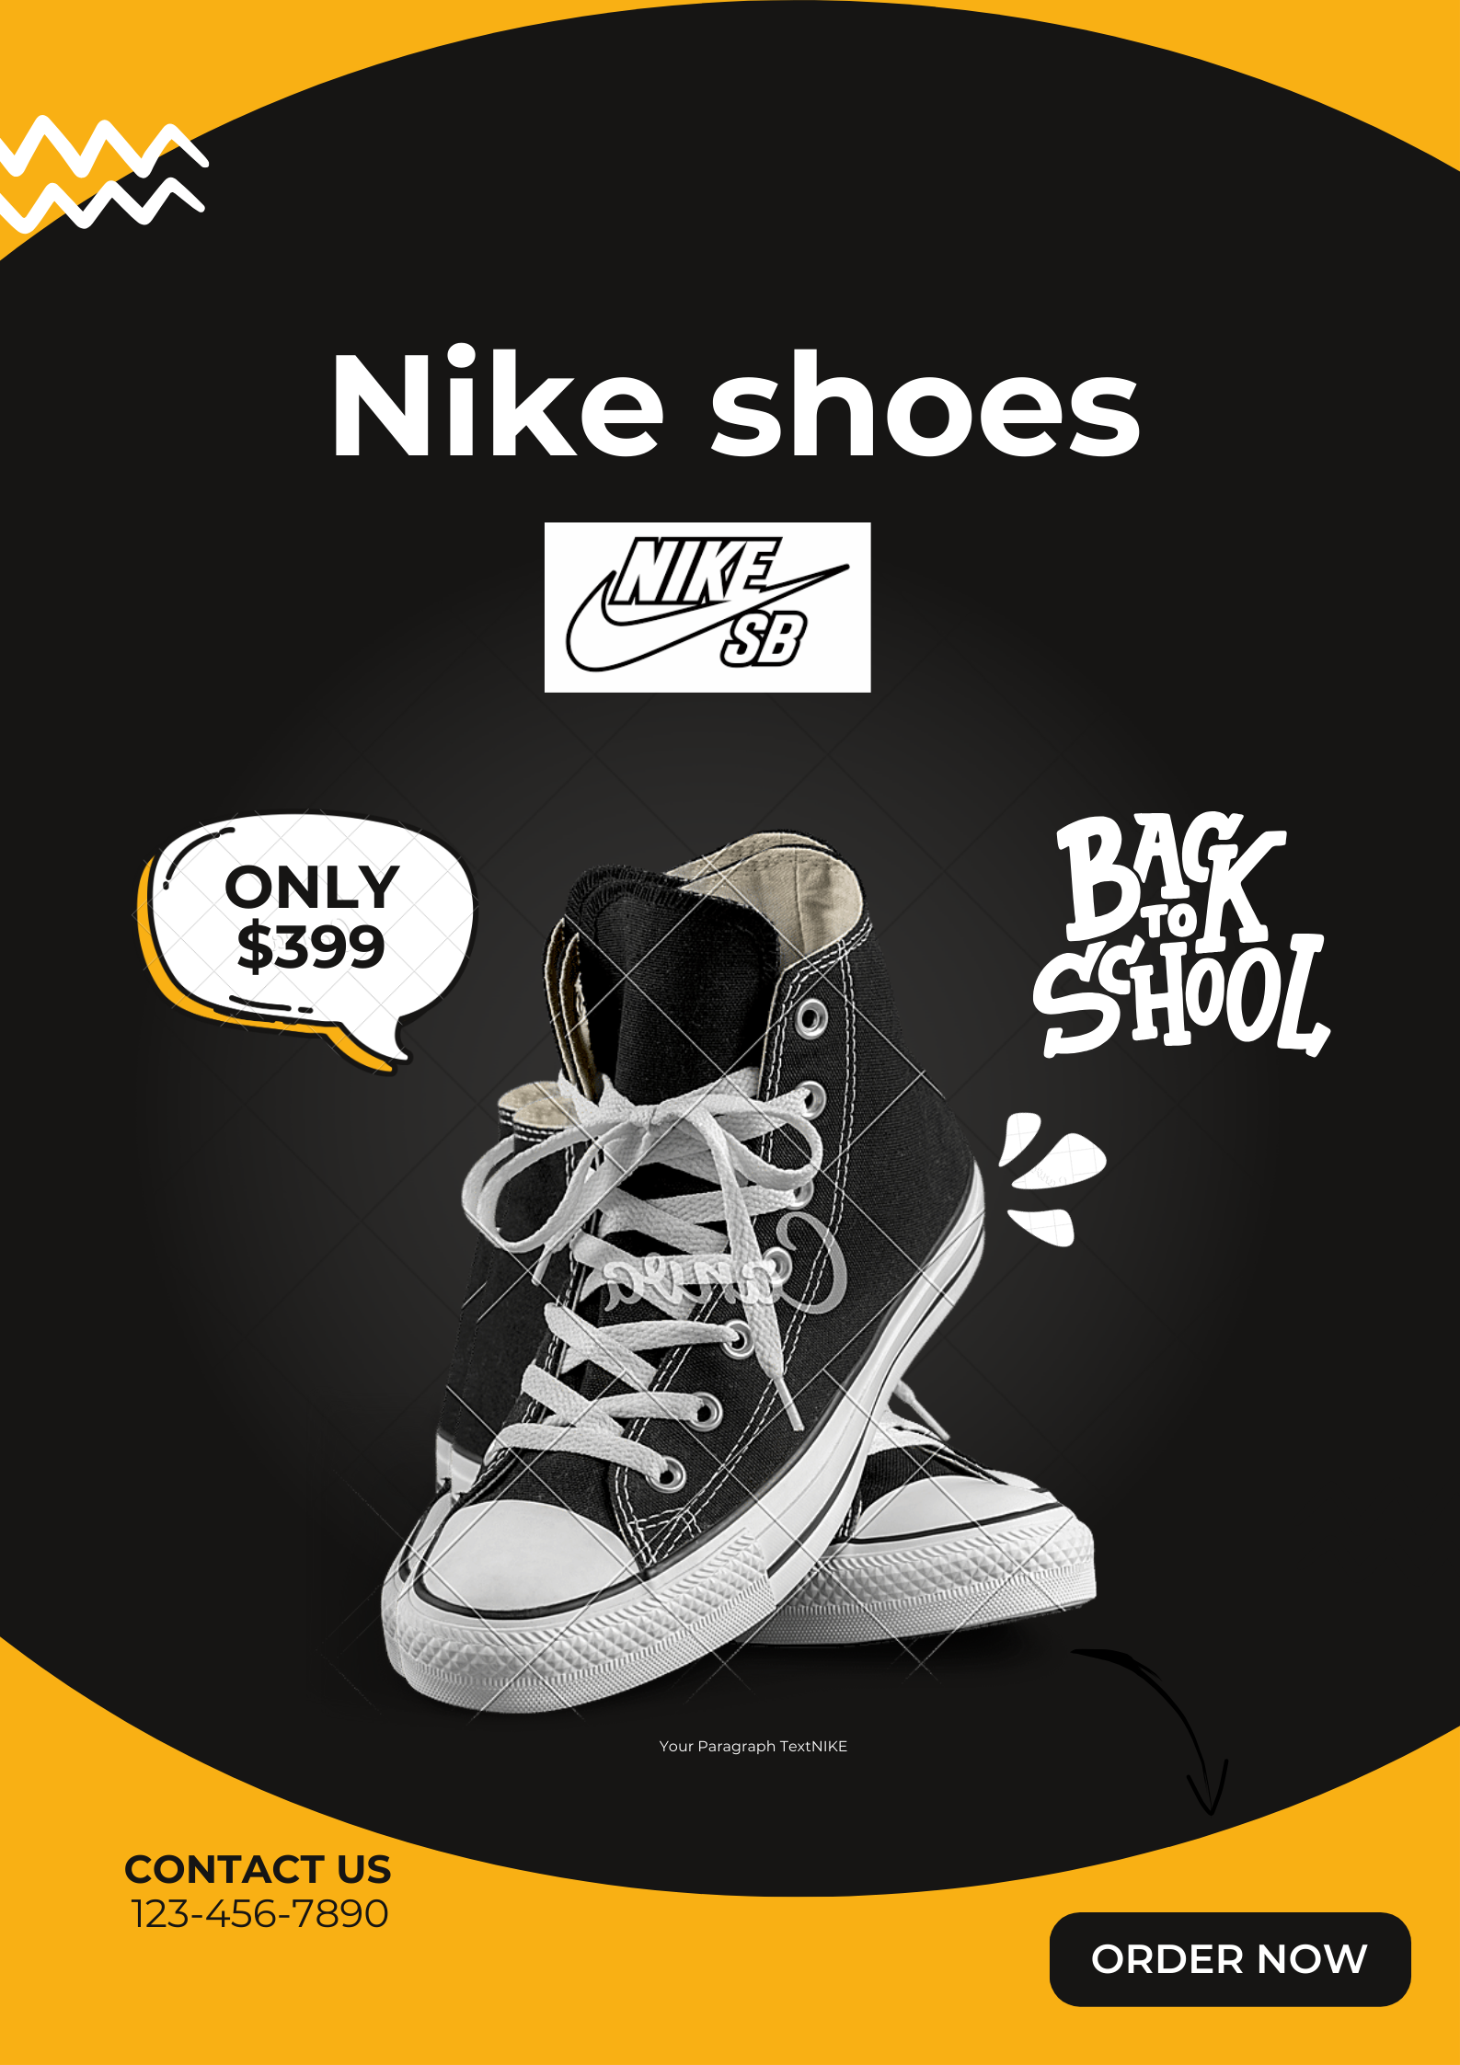

**Fig: Social media poster on a Nike brand shoes**